**Steps To Connect To Car :**

1. **Go To Wi-Fi Settings**
2. **Select (Autonomous car )**
3. **Insert Password ( auto2244 )**
4. **Go to 192.168.1.100**
5. **Enjoy playing**

**Autonomous driving and Vehicle tracking**

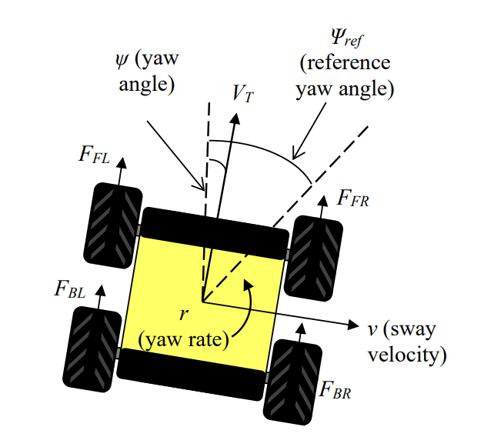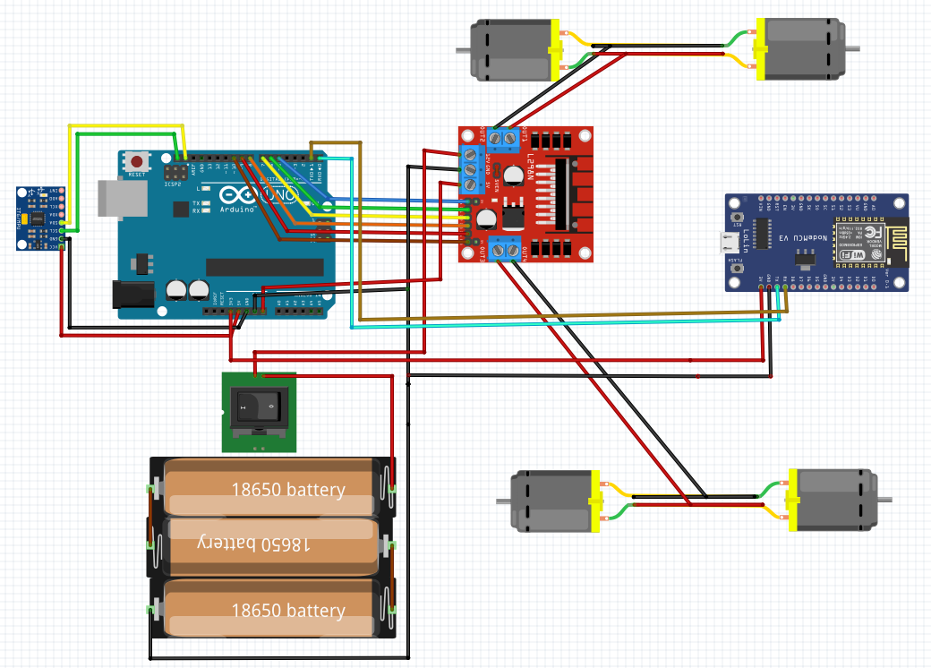

**Team Members :**

Abdelrahman Shrief - Sondos Reda - Mohamed Alaa - Asmaa Mohamed - Mohamed Hossam - Mahmoud GabAllah - Mohamed Nageh - Moamen Morad